THE FORT is with them: Group fighting to bring historic Fort Velasco back to Surfside Beach

HOLLY PARKER/The Facts
James Glover points out some of the features of Fort Velasco as he looks at the original plans for the fort Tuesday as they hang in the Surfside Historical Museum at Surfside Village Hall.
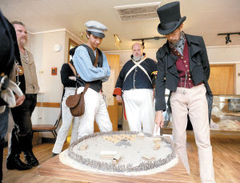
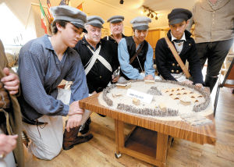
Posted: Wednesday, June 26, 2013 2:00 am
By ALAN NIESCHWIETZ | 0 comments
Just like it was 171 years ago, people here are engaged in a fight centering around Fort Velasco, only this time the struggle is about rebuilding it.
This modern group also believes it will be as successful as the Texians who took on the Mexican garrison at the Battle of Velasco on March 26, 1832.
“What it needed was after all these years to just have some people take hold of it and just do it,” said Surfside Historical Commission member Ron Grant, who credited the late Jim Bedward for providing much of the new impetus for the project.
Standing next to a scale model of the fort in the museum at Surfside Beach Village Hall — which is about 150 yards from the actual site of the fort — the 32-year resident of the island said the effort might not bear fruit right away, but it will happen.
“If it’s not looking good this year, we have something to strive for next year,” Grant said. “We’re going to make this work.”
Aiding the effort immensely is the original fort actually was a pretty humble military emplacement, made of logs and earth, commission member Dortha Pekar said.
“It’s doable,” she said about the project, gesturing toward one of several depictions of it in the museum. “Look at it. It’s not going to be a great architectural feat.”
James Glover, a local historian and member of the Brazoria County Historical Militia, acknowledges it isn’t the first time this idea of rebuilding the fort has made the rounds. He is working to see that something actually comes out of the discussions this time.
“There’ve been attempts in the past to do this,” he said. “The closest was probably in the ’70s.
“At this point it’s in the preliminary stages,” Glover continued, “but it’s got to start somewhere.”
Where the effort needs to end up, however, is $250,000 to $300,000 raised through donations and grants, and not from tax dollars, Grant said.
Commission member Lou Golish sees what’s being attempted as a necessary part of a larger effort in the area to embrace its colonial and republic roots.
“This needs to be done for the sake of the history of Texas,” he said.
The battle itself occupies a unique place in that history. While a few will go so far as to call it the first battle of the Texas Revolution, Glover isn’t one of them.
“It wasn’t part of the Texas Revolution, but it was a prelude,” he said. “Some wanted it to erupt in full-scale rebellion, but the majority wouldn’t support it.
“In fact,” Glover said, “there were people who applied for pensions based on their service here during the battle, but were denied because even back then it wasn’t considered part of the Texas Revolution.”
Even if it wasn’t the place were the revolution began, it was the place where it ended, with Mexican dictator Santa Anna signing the Treaty of Velasco there, he said.
The fort lasted until roughly the time of the Civil War, when a series of hurricanes destroyed it, Glover said. But, being made in large part of earth, traces of it still exist, he said.
“You can actually see it if you know what you’re looking for,” Glover said.
Well aware the high tide raises all boats when it comes to attractions for tourists to visit, commission members and others involved in the effort are seeking to make rebuilding the fort a regional undertaking, Pekar said.
“Redoing the fort will be a big draw for the rest of the county, too,” she said.
Glover agreed, and said its placement makes it ideal for other spots in the county.
“The beautiful thing about tourism in Surfside is that for the out-of-town folks to get here, you have to go through the rest of the county,” he said.
The commission will have its first fundraiser for the fort with a dinner on Sept. 20, the night before Texas Navy Day activities on the island, Glover said. The invited guest speaker that evening will be Jim Bevill, an authority on the history of republic-era Texas.
People looking to buy tickets for that event, or to learn more about the effort to rebuild Fort Velasco, can call contact a commission member through Village Hall at 979-233-1531. Donations can be mailed to Surfside Historical Commission, c/o Surfside Village Hall, 1304 Monument Drive, Surfside Beach, TX 77541.
Alan Nieschwietz is a reporter for The Facts. Contact him at 979-237-0151.

